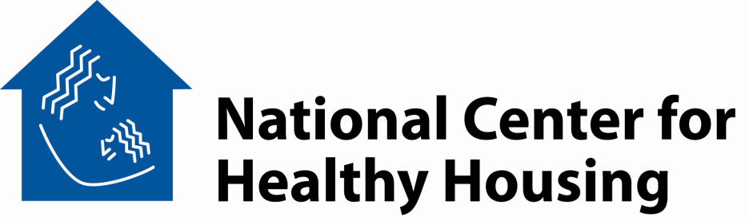

**Code Inspection for Healthier Homes**

**Agenda**

Duration Topic

5 min Welcome / Course Overview

30 min Making the Connection Between Health and Housing

* Institute of Medicine Reports on Asthma and on Dampness
* Group Exercise

20 min American Housing Survey – Snapshots of the Problem

* Trends – 2005 to 2007
* Metropolitan Statistical Areas – Comparison to National
* Interior-Exterior Relationships

20 min Property Maintenance Codes and Health

* State Codes
* Local Codes
* International Property Maintenance Code

15 min *Break*

20 min Code Enforcement Strategies

* Complaint-Based Inspection
* Systematic Inspection
* Certificate of Occupancy
* Education and Accountability

15 min Landlord-Tenant Law

40 min Handling Special Issues

* Pests and Pesticides
* Mold and Dampness
* Lead and Deteriorated Paint
* Radon and Asbestos

10 min Wrap-up and Review

*Adjourn*

# Building a healthy home environment for all children

10320 Little Patuxent Parkway, Suite 500, Columbia, Maryland 21044 ⬩ 410.992.0712 ⬩ FAX 443.539.4150

www.centerforhealthyhousing.org