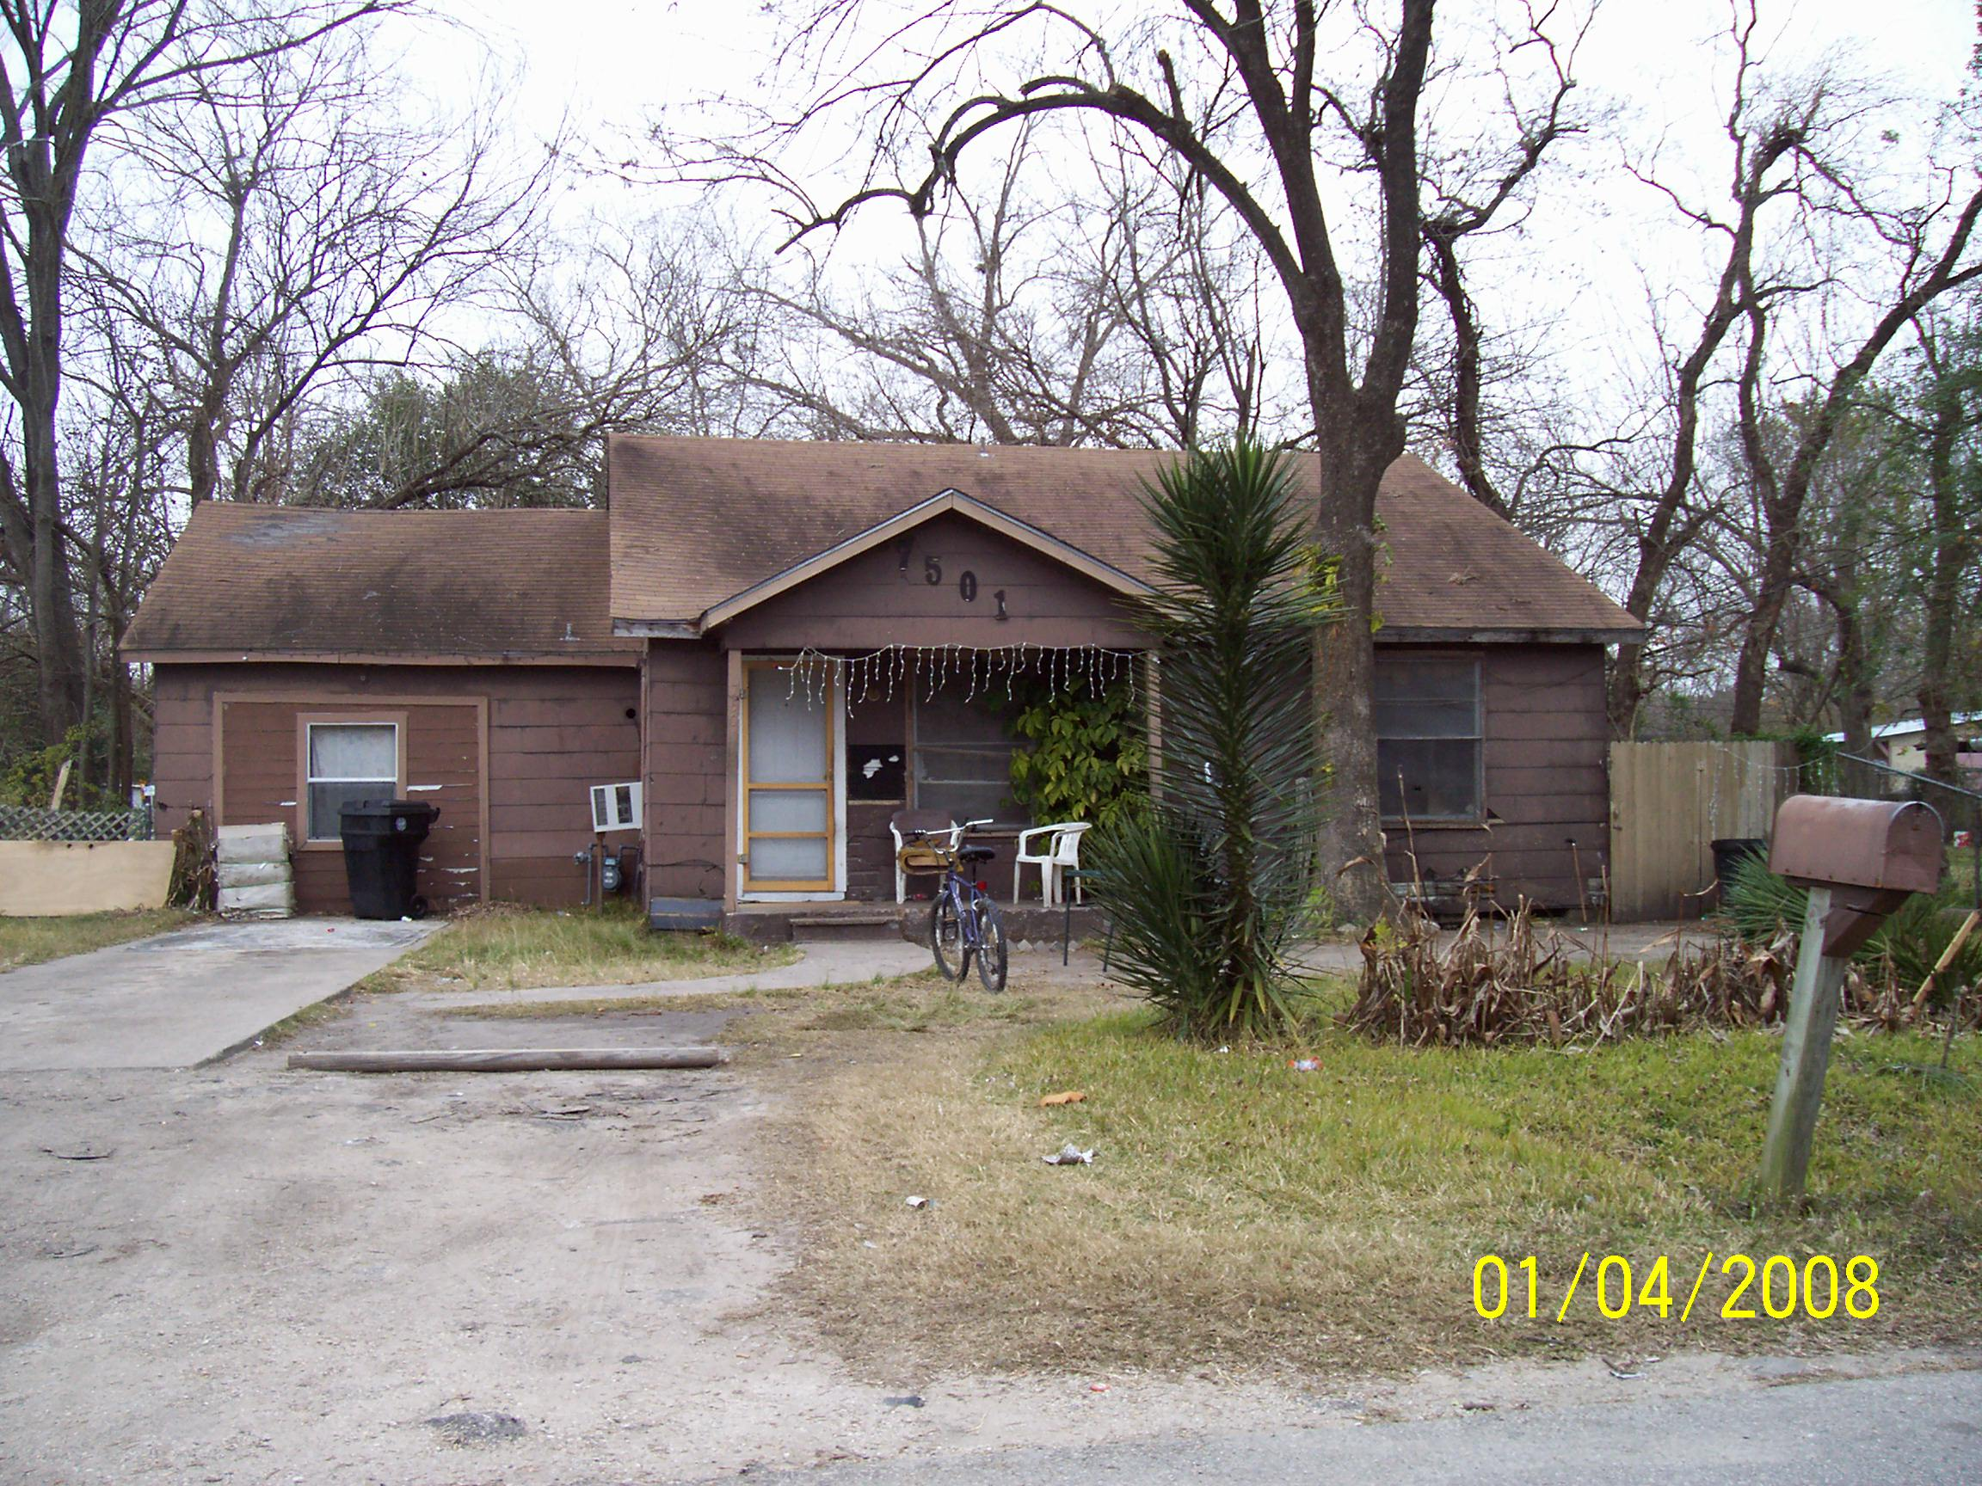

Gulf Coast Weatherization Scenario
- Property Characteristics
- Two bedroom, single family circa 1950
- Wood frame with asphalt roof
- Single story with slab on grade
- Original, single pane, double hung window sashes
- Weatherization Audit Findings
- 4 people live in house, two adults (mother & elderly grandmother) & two children (1 under six years old)
- Overall building conditions are fair
- Insufficient insulation in the attic – ¾” fiberglass
- Walls limited or no insulation
- Gas, forced hot air heating/cooling system, furnace filter dirty
- Duct work in attic not properly sealed
- High CO levels from old gas hot water heater
- Mold on bathroom ceiling & walls, bath fan not working
- Electric dryer with damaged vent
- Unvented space heater
- Damaged paint on old windows
- Leaking gas hot water heater in closet
- Weeds growing out of gutters & some downspouts missing
- Healthy Concerns
- One adult & one child have asthma, suspected dust allergy
- Grandmother is unsteady, walks with cane
- No working smoke or CO monitors
- Problem with cockroaches in kitchen and bedroom
- Possible Lead Based Paint on windows
- Gas range with no vent
- Carpeting is soiled in many spots
- Mold on bathroom ceiling & walls, bath fan not working
- No grab bars in bathroom – fall hazard

- Remediation Response
Weatherization Actions
- Insulate attic & walls
- Seal duct work with mastic
- Air sealing and weather strip
- Install smoke and CO alarms
- Replace gas hot water heater with efficient heater
- Provide and install CFL bulbs

Potential Health Responses
- Clean mold in bathroom & replace sheetrock if necessary
- Install timed, bathroom fan, confirm venting to exterior
- Replace dryer vent
- Change furnace filter supply MERV 8 if system can accept it
- Seal holes for roaches, and provide owner with Integrated Pest Management (IPM) advice or IPM services
- Install range hood fan vented to the exterior
- Replacement hot water heater is direct vent or power vented
- Remove old carpet, smooth cleanable flooring in one room - may be outside scope of some programs
- Make referral to lead poisoning prevention program
- Conduct asthma education visit. Supply mattress covers, HEPA vac & other materials as needed

