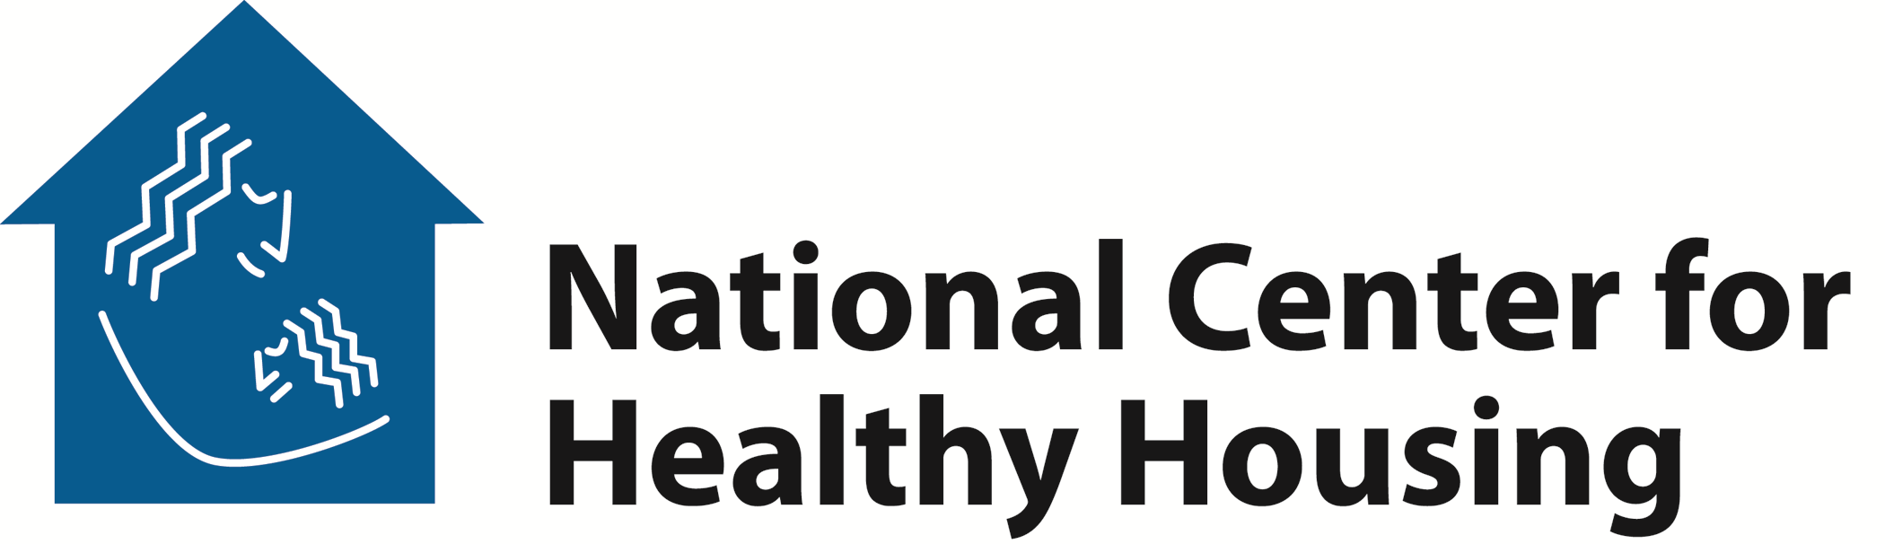

Hurricane Aftermath: Ten Tips To Protect Your Family from Housing-Related Health Threats

Mold
- Children, elderly, immuno-compromised, allergic, and asthmatic individuals should NOT be present in the building until the cleaning or repair is finished. Mold can trigger asthma attacks and can make respiratory problems worse.
- If the house has been closed up for several days, enter briefly to open doors and windows to let the house air out for at least 30 minutes.
- Protect yourself by wearing rubber boots, rubber gloves, an N95 particulate respirator (available at most hardware stores), goggles and a shower cap during clean up.
- Take appropriate measures to dry out the entire structure of the house or apartment building. As soon as safe, reliable power is restored, fans; dehumidifiers; window air conditioners; and undamaged, uncontaminated, properly filtered HVAC systems can be used to dry out a building.
- If you suspect that the heating/ventilation/air condition (HVAC) system may be contaminated with mold, have the system service and cleaned before you turn it on.

Carbon Monoxide Poisoning
- Do not use gasoline-powered generators, open flame camp stoves and lanterns, or charcoal or gas grills in any building. Unvented combustion devices can cause rapid and dangerous increases in carbon monoxide concentrations in indoor air.
- Property owners should check and, if necessary, repair all damaged water heaters, furnaces, and other combustion appliances such as natural gas-powered ovens and stoves.

Pest Infestations
- Remove all wet materials and personal belongings from the house or apartment building. This includes all wet wallpaper, wallboard, carpeting, throw rugs, bedding, mattresses, box springs, stuffed toys, clothing, and any other wet materials that cannot be adequately dried. Inadequate drying of these materials can attract large cockroach infestations
- If pest infestations are already present, avoid the use of high-toxicity pesticides. Instead, use gel baits and bait stations for cockroaches and ants, and employ traps and tamper-proof bait boxes for mice and rats.

Damaged Lead-Based Paint
- If paint has been damaged, remove it using lead-safe work practices such as wet scraping and wet sanding. Be sure to seal off any areas where repair work is being done, and cover the entire floor with plastic sheeting. Make sure to wear clothing you can dispose of after repair work is completed, and be sure that all areas have been cleaned with hot, soapy water. Never use sandblasting to remove paint from houses or apartment buildings constructed before 1978, never use heat guns or torches, and never use dry sanding or power sanding methods unless the equipment is properly fitted with HEPA-filtered vacuum devices. Where possible, use contractors specifically trained in lead-safe work practices.

