A Workbook for Using Future’s Tools in Strategic Planning

A Workbook for

Advancing Safe and Healthy Homes for Children and Families Initiative Sponsored by The Kresge Foundation

“The future is what we make of it”
Pamela Shaheen

This workbook was prepared by
Pamela Shaheen, Dr. PH,
Program Director
The Advancing Safe and Healthy Homes Initiative (ASHHI)

Adapted from
The Wiser Futures Workshop Compendium: Using Futures Tools to Better Understand and Create the Future
Created by
Clem Bezold, PhD,
Chairman & Senior Futurist
Institute for Alternative Futures

Dear Colleagues:

We have prepared this workbook to provide grantees engaged in the Advancing Safe and Healthy Housing for Children and Families Initiative (ASHHI) with a new set of tools they can use in strategic planning. The tools discussed here are those used by Futurists. They provide a different lens through which organizations can consider the future more deliberately. While most of us involved in strategic planning tend to view the future as an extension of the past, the application of future tools forces us to take a broader perspective - one that considers a set of alternative futures so the organization can be flexible if the future anticipated is not the one that unfolds.

To accomplish this, the Institute for Alternative Futures (IAF) has developed ‘aspirational futures’ model – an approach that combines learning about the future and its uncertainty with vision and creating preferred futures. Using an aspirational futures approach involves understanding what might happen (likely and alternative futures) and a clear and shared commitment (between board and staff) to creating the organization’s preferred future.

Although this work book provides an introduction to the futures field, we believe it contains sufficient information to allow any organization to use the tools here in described for planning purposes. To borrow a title, consider it to be “Using Futures Tools for Dummies”.

We are convinced that the application of these tools will lead to better outcomes for the organization(s) involved – allowing organizations to better define their preferred future. And, as Peter Schwartz – a prominent futurist has observed – they can be used as building blocks for designing strategic conversations. Such conversations can lead to continuous organizational learning about key decisions and priorities.

So, enjoy learning how to use them and to apply them in your organization’s planning processes. We hope they allow you to experience a better future than the one you anticipated!

Clem Bezold Pamela Shaheen
TABLE OF CONTENTS

- Introduction 1
- The Aspirations Model 6
- Foresight for Whom and for What? 9
- Key Aspects of Aspirational Futures – Environmental Scanning 10
- Developing Forecasts 15
- Scenario Development 17
- Framing a Vision 26
- Audacious Goals 29
- Understanding and Leading Change 31
- Concluding Comments 36
- Appendices 37
Appendix 1: Futures Terminology 37
Appendix 2: Additional Futures Resources 40
Appendix 3: Additional Resources for Environmental Scanning 42
Appendix 4: Sample Workshop Exercises on Using Future Tools 44

This workbook would never have become a reality without the help of: Cheribeth Tan-Schriner, Danielle Lepar, Linda Collins and Alanna Woolley. We are forever grateful for their contributions.

- Introduction

- The Challenge

All of our experience is with the past, but all of our decisions are about the future. Leaders at every level have usually assumed that their past experience is a fairly reliable guide to the future—the future will simply be a bigger and better version of the world with which they are familiar. This kind of continuity of change, however, can no longer be taken for granted. In area after area today, we are confronted by true uncertainty: we really do not know what will happen, but we know it is happening more quickly!

In the first part of the 21st century we are entering a very different world. The pace of change is accelerating. For example, in the fields of information technology, communications, and biotechnology, major advances are occurring in the range of every 12 to 24 months, in some cases making what we have known obsolete. Over the next 25 years certain technologies could advance almost a million-fold. With changes of this magnitude, the world becomes a fundamentally different place - one that we have little idea of how to cope with.

Throughout history it has always been difficult for individuals and organizations to adapt to change – consider the challenges faced in the shift from an agrarian to an industrial society – a shift that took more than 50 years to complete and yet, the entire transition was problematic.

A more immediate example is the evolution of the mobile phone (Figure 1). It has gone from it being a mobile landline to an extremely a smart mobile phone in just under 30 years!

Figure 1
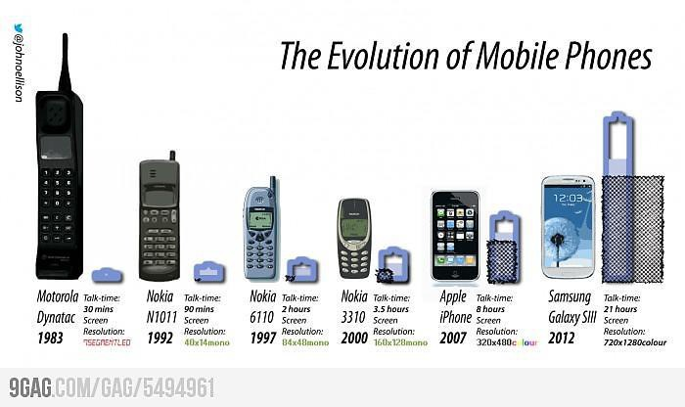
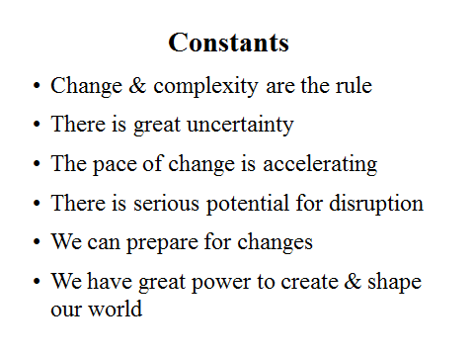
Given this ever-accelerating rate of change, we have no choice but to learn to adapt much more quickly – both for our organizations and ourselves. These acceleration dynamics make it far more important for every organization to create the future it prefers rather than simply adapting to its changing environment. The opportunity to remain a Luddite is no longer viable.

With change such as this, the world becomes a fundamentally different place.

- Aspirational Futures – A Frame of Reference

While many organizations develop strategic planning processes, the most successful include a futures component. This involves understanding what might happen (likely and alternative futures) and a clear, shared commitment to creating the organization’s preferred future. Both the understanding of the future and an effective commitment to creating it are essential, and they form the basis of the Institute for Alternative Futures’ (IAF) Aspirational Futures Approach. This approach forms the basis for this workbook.

The Aspirational Futures approach is about better understanding the future and better creating the future.

A central concept of IAF’s Aspirational Futures Approach, is that an organization should deliberately envision and plan to create a preferred future for itself and its stakeholders. The preferred future embodies an organization’s most fundamental values and principles and its highest aspirations. The organization’s vision provides a sense of meaning and framework for how people in the organization and stakeholders can make a contribution to creating a preferred future, one reflecting their values and goals as an organization. Envisioning and creating a preferred future reduces the risk that the latest strategic planning effort will simply re-create the status quo.

There are six recommended inter-related phases in the Aspirational Futures (Figure 2): 1) Environmental Assessment, 2) Developing Forecasts, 3) Scenario Development, 4) Visioning to Clarify Aspirations, 5) Identifying Goals, and 6) Strategic Analysis.

Figure 2

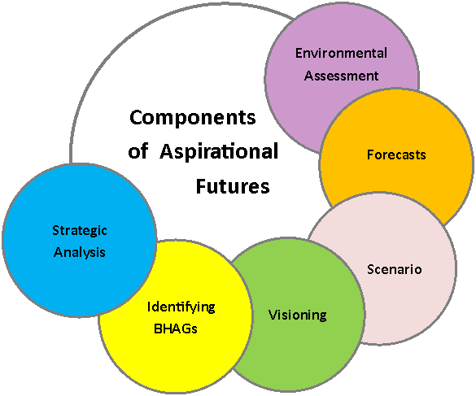
Inter-related Phases of Strategic Futuring

Conducting an Environmental Assessment

During this phase, the organization scans a broad range of topics including: global, political, economic, technological, environmental and social trends. Information is gathered from a variety of sources, such as literature reviews, expert interviews, focus groups, blogs, group and automated scanning services, surveys, and site visits. Next, Trends that could affect the organization are identified. A trend is a pattern of change over time in something of importance to the observer. These trends are evaluated to identify Key Forces shaping the future i.e. – those trends with the greatest impact potential and the highest levels of uncertainty. Through the use of forecasts these key forces are then projected into the future.

Assessing trends and key forces can reduce some uncertainties about the future, but cannot eliminate them. They can, however, highlight just how great the uncertainties really are.

Doing Forecasts

Forecasts provide specific estimations of a particular outcome or event at some future point in time. In the Aspirational Futures approach, forecasts are created using the drivers (forces that move a system) and key forces identified and explored in the environmental scanning phase. Forecasts are important in providing planning assumptions. They can help determine future courses of action and can also be used to develop goals for an organization.

- Developing Scenarios

To deal responsibly with the uncertainties requires a style of thinking that is based on creating various stories called Scenarios. Scenarios allow us to imagine alternative views of the future - views that embrace and explore uncertainty instead of ignoring it. The key forces and forecasts identified through environmental scanning are important for constructing scenarios.

Scenarios serve three purposes:
Using scenarios is not a matter of memorizing Plan A or Plan B - because in the real world, A and B overlap and recombine in unexpected ways. It is a matter of training yourself to think through how things might happen. To have at hand the answer to the question, “What if……….?”
- Peter Schwartz
The Art of the Long View
    - To bound the range of uncertainty and display the broad range of possibilities ahead.

    - To stimulate participants to explore both the dangers to be avoided and opportunities that can be used in constructing a vision of the preferred future.

    - To test how potential strategies and actions might work in different future circumstances, in order to identify the most “robust” strategies that make sense across a wide variety of future conditions.

- Creating a Living Vision

We are going to see organizations increasingly assume that what they stand for - in an enduring sense - is more important than what they sell.
- Collins & Porras

Most organizations have a vision statement. In many instances, they are simply there but never utilized as a pathway to a preferred future. To make a vision come alive and provide meaning within the organization, it is important that it be powerful and widely shared across the organization. To make this happen involves creating a new vision or updating an existing vision to insure within the organization that it is deeply felt by all concerned and viewed as a shared vision of the preferred future. Once this vision has been adopted the organization can then identify the key goals it wants to pursue - in alignment with the shared vision.

While trends and scenarios are “futures for the head”- helping us think systematically about future possibilities - visions are “futures for the heart.” Visions inspire by:

- Stating that which we are striving to become,
- Why we do what we do, and
- What higher contributions flow from our efforts.

Visions touch us and move us to action. A living vision – as opposed to merely words on paper—is something that people share, feel deeply about, believe is possible, and commit themselves to achieving.

Most importantly, visions deal with the ultimate questions facing every individual, group and organization:

- What’s our purpose,
- What meaning do we bring to the world,
- What direction will our lives will take and,
- What is our reason for existence.

When people are truly committed to a vision, they will stretch themselves and their organizations to make it happen. Within organizations, having a shared vision allows management to decentralize. People can be given more freedom to act independently and creatively when they have a clear sense of direction and know how important their contribution is to realizing the organization’s vision. A shared vision serves as a clear benchmark for collaboration within and outside the organization and it’s alignment in the world.

To be a real force in people’s hearts, and not just words on paper, a vision must be legitimate, be shared, express people’s highest aspirations for what they want to create in the world, stretch beyond the limits of current realities, and be conceivably achievable within a specific time frame – but not in the near future.

- Identifying BHAGs

BHAGS are Big Hairy Audacious Goals. The term was coined by Collins and Porras in their bestselling book, Built to Last: Successful Habits of Visionary Companies. Often referred to as ‘stretch goals’, BHAGs are designed to make the vision real. They must be bold enough to make people ask themselves “Is this really possible?” Once the inner answer is “Yes,” the vision and goals’ very boldness become the major source of their power. Because they articulate a daring adventure with important outcomes, BHAGs give people the sense they can make important contributions well beyond what they thought they were capable of.

- Conducting a Strategic Analysis

Once a vision and goals have been articulated, the more “traditional” aspects of creating a strategic plan, particularly strategies and action plans, are needed to focus efforts on achieving the vision. Visioning and strategic analysis are equally important for shaping the future. Without a clear vision, strategy is merely reactive. Alternatively, without realistic strategies to achieve them, visions are only lofty ideals. Each proposed strategy must undergo a detailed analysis to consider internal and external requirements for success, robustness, risks, outcomes and audacity.
- The Aspirations Model

IAF’s Aspirational Futures approach grew out of a belief that using futures tools should enable an organization, once it has an understanding what might occur, to create a wiser preferred future. To do so effectively, individuals in the organization must understand the two distinct mindsets or cultures that arise within individuals and organizations. These distinctions are depicted in Figure 3.

Figure 3
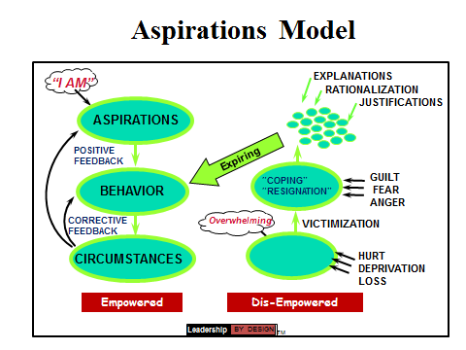

As a starting point we need to understand that our aspirations (our definition of the preferred future) drive our behaviors (what we say, do, think and feel) which, in turn, shape our circumstances in the world around us. These three factors are depicted in the green ovals on the left-hand side of the model. More specifically aspirations shape both personal and organizational behavior. When our behaviors are effective in making positive changes in the external circumstances, then the organization’s aspirations are reaffirmed they create an arc of “positive feedback” – the larger arc on the left hand side of the model. When behaviors prove less effective, the organization receives “corrective feedback” that highlights the need to revise or refine some behaviors – the smaller arc on the left hand side. Either way, the organization is able to respond to circumstances in ways that are aligned with its aspirations.

Alternatively, on the right-hand side of the model, instead of aspirations driving behavior, circumstances drive behaviors. In this case, the organization becomes a “victim of circumstance.” It continually reacts to the crises around it, producing not a reaffirmation of aspirations but rather an “exhaust cloud” (the sprinkling of small green dots at the top right of Figure 3) of explanations, rationalizations, and justifications. This cloud reflects blame, guilt, and anger, and excuses inaction. Organizations that are consistently on the right side of the model do not have an “aspiring culture” but rather an “expiring culture.”

The framework is useful tool in focusing the organization on its aspirations, rather than its circumstances. It can make us aware of how easy and common it is to have circumstances change and be driven by them i.e. becoming a “victim of circumstances.” By aligning behaviors with aspirations, organizations can identify strategic initiatives that will lead to surprising successes that reaffirm their shared aspirations. Bottom line, the goal is to stay on the left side of the model.

The Approach provides a number of advantages beyond traditional strategic planning because it:

  - Emphasizes planning “from the future.” Asking the organization what world it wishes to create and then systematically developing a plan to get it there.

  - Focuses the organization on its long-term preferred future – one extending out 3 – 5 – or more years. Many strategic and organizational plans are for short periods of time. However confining the plan to reflect only the next one to two years often causes them to lose their audacious quality, narrowly restrict their options and set too-easily achieved goals.

  - Facilitates an explicit discussion of the organization’s vision, values and mission. Most strategic planning processes move quickly to evaluating specific strategies in light of existing mission or organizational imperatives. Through this process participants are invited to explore an organization’s “heart” first – a step that re-introduce participants to the organization’s essential characteristics before moving into decision making mode – the ‘head’.

  - Assures that the audacious goals chosen are driven by the organization’s vision, values and guiding principles. Textbook strategic planning typically proposes that goals and measures be established once the final strategies are selected. Aspirational Futures asks participants to identify goals consistent with their vision, values and principles and then to select specific strategies that will achieve these goals in a manner that is aligned with the organization’s vision, values and principles.

  - Emphasizes scenario development to ‘force’ strategic decision-makers to examine at least four alternative futures before making strategic decisions. Scenarios stretch the strategist’s imagination, offer insights into how the organization’s environment may evolve and create unique creative dialogues that can generate new ideas for consideration. All too often, strategic planning processes consider only one future - a future that assumes that tomorrow will be very similar to today.

  - Takes advantage of the dynamics between the external environment and the organization’s internal capacities. Most planners ask what an organization can do with its resources and pay relatively little attention to trends that may create new resources.

  - Asks leaders to examine what resources the future will make available. By exploring trends and developing scenarios the planning process helps organizations recognize opportunities and threats that remain invisible in a traditional strategic planning approach.

  - Emphasizes stakeholder participation and empowerment. To be most effective, the process needs to be highly participatory - involving internal and external stakeholders in a structured dialogue and decision-making process.

- Foresight for Whom and for What?

Foresight involves taking a longer and broader view of decision-making. Foresight is used to provide an early warning system to: identify emerging issues, understand challenges and opportunities, clarify vision and goals, and check the appropriateness and “robustness” of strategies. Foresight enables organizations to more wisely create their futures.
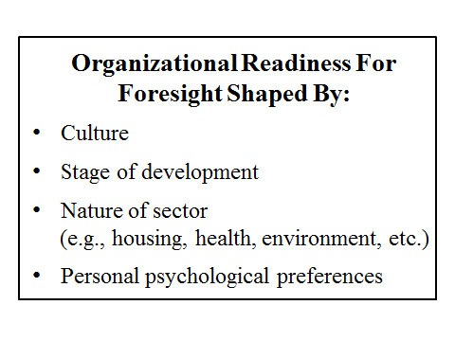
Most foresight is done by and for governments and organizations with a unitary focus that is not sensitive to differences or disparities among the affected populations. There is, however, an increasing awareness of the need for and appropriateness of using future’s tools to consider disparities and equity or fairness in foresight. Environmental and health impact assessments reflect this awareness. This is part of a larger trend – creating a movement to recognize the need for fairness and equity in all policies – especially those impacting vulnerable populations. Like the efforts to abolish slavery, support women’s rights, and recognize the legitimacy of the gay community, these movements grow over time.

In response to this increased focus on equity, fairness and vulnerable populations, these analyses are beginning to incorporate two that reflect this approach are: the development of a Health Impact Assessment (HIA) model that considers the health and equity impacts of decisions or programs before they are put in place and a parallel approach, Health In All Policies (HIAP) which states that– as policies are being developed the health and equity consequences must be considered.

- Key Aspects of Aspirational Futures - Environmental Scanning

This and the next four sections provide additional detail on how to utilize this approach in strategic planning conducted by your organization.

- Environmental Scanning

The first step in thinking about the future involves scanning the external environment to identify trends. A trend is a pattern of change over time in things of importance to the observer. Some trends are well known e.g. how the impending retirement of the Baby Boomers will impact the workforce. However, environmental scanning can also provide greater depth to an issue and help you identify future problems or opportunities not currently on your radar screen. For example, while most Not for Profit Organizations (NPO’s) are very aware that their shrinking revenue base– either the result of funding reductions or the growth of additional, competing NPO’s - they are often not aware of the opportunities created by partnering with other NPO’s to grow the total revenue ‘pie’.

By identifying existing trends and emerging developments, you can set the stage for thinking about future possibilities that may result from the unfolding of these trends. For example, considering the trends in funding for your core programs, being aware of a technology that would alter how or what your nonprofit does, and thinking about how you might react or change makes you more ready to adapt to those changes more effectively.

All of us do scanning all the time. We watch the news on a variety of media as well as conversing with individuals to get feedback on what we are thinking and to identify new opportunities. Scanning as a futures tool formalizes this activity and applies what is learned from scanning to the needs of your organization in a structured way. You can then include this learning in specific projects and ongoing operations. Environmental scanning, like the other futures processes, can also lead us to search and observe differently, giving a greater context to how we interpret what we see and hear.

Figure 4
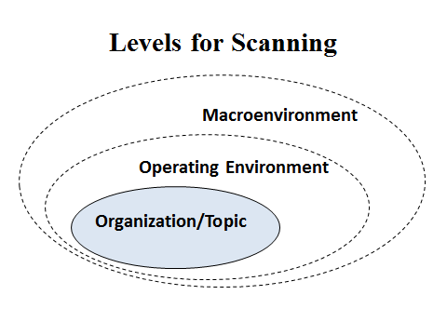
Scanning considers changes relevant to your organization. This involves gaining a greater understanding of the forces shaping your organization or the topic you are focusing on. When considering trends in the external environment, it is often relevant to differentiate trends in the Macro-environment (affecting the economy and society generally), and the Operating Environment (specifically relevant to your sector, i.e. healthy housing). Focusing on the macro and operating environments will become important in considering drivers

(elements that are the key forces shaping the topic being considered) and in developing scenarios as well.

- Developing Scanning as a Technique

Scanning involves searching through various information sources to identify trends and emerging developments. Most individuals do scanning all the time – especially since we have become steeped in social media. Government agencies, not for profit and for profit agencies likewise monitor relevant media, trade publications, scientific or technical journals related to their line of work. Organized scanning can be as informal as a group discussion of what participants are observing or as formal as a well-funded formalized system to monitor trends. Scanning efforts are best done on a continuing basis to provide a ‘futures radar’ that constantly functions to identify emerging threats and opportunities.

Three important decisions about the scanning process arise as the approach is designed.

  - The first is specifying the audience (who in the organization will learn from the scanning) and what the objectives are (e.g. enhancing ongoing operations, identifying new product opportunities, and/or exploring competitive or other threats.)

  - The second is to determine the level of resources and sources to be used: how many internal staff will be involved and for what percentage of their time. What outside resources will be used e.g.: having another organization conduct the scanning and/or the scanning and briefings. Organizations with higher budgets and more staff with content expertise are able to scan a wider variety of sources and to explore sources that are further ‘upstream’, i.e. those studying weak signals and emerging trends that will affect a longer-term future. There are ever growing web-based scanning and aggregating services or apps that can be significant.
Figure 5
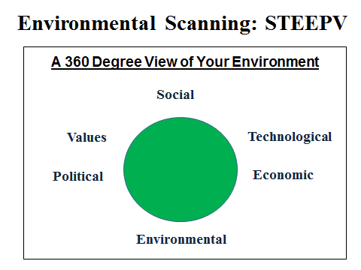
  - The third decision involves choosing a framework for environmental scanning. As noted above, it should include the macro - environment and the operating environment. A classic framework is STEEPV (Figure 5), standing for Social, Technological, Economic, Environmental, Political and Values, which ensures that each of these areas is scanned for developments important to the organization.

To see an example of STEEPV go to: (http://www.altfutures.org/pubs/WiserFutures/WiserFutures2013Appendices.pdf).
Scanning and the interpretation of the significance of the trends observed, is affected by our mental models. A mental model is an explanation of someone's thought process about how something works in the real world. It is a representation of the surrounding world, the relationships between its various parts and a person's intuitive perception about his or her own acts and their consequences. Mental models can help shape behavior and establish an approach to problem solving using an algorithm - a set of rules for solving a problem in a finite number of steps. In many cases, as individuals, we are unaware of our mental models, yet these implicit assumptions focus and limit what we observe.

- Steps for Environmental Scanning

Here are some common steps to help guide you in developing an environmental scanning process:
- Brainstorm a list of sources relevant to the topic you’re covering. Conducting a brainstorming session with your team is a good starting point. About half of the list should be go-to sources that you are familiar with. These can be futures organizations, think tanks or popular media that cover a wide variety of topics. These sources will often cover trends in the “macro-environment.”

You should also develop sources focused on the “operating environment” aspects of the topic. For example, if the scanning is being used in the development of scenarios on the future of health and housing, the sources need to cover developments in this area. Sources that can be tapped include: HUD’s Office of Healthy Homes and Lead Hazard Control, the CDC, the National Center for Healthy Housing, as well as numerous other organizations that operate in this sphere. Often your peers are great sources of information. In addition, much can be learned at conferences where healthy housing is a major topic of discussion. And, there’s always lots information that can be found on the Internet.

- Plot out your sources. Using a framework like STEEPV, plot out the areas your sources are likely to cover. If certain topic areas are not well covered, do some Google searches for relevant sources or contact other experts to ask them what articles, experts or other sources they recommend. If you have a lot of sources in one area, it may be worthwhile to cut back a bit, unless you think that topic will be very important to the forecasts or scenarios you are developing.

- Conduct your own scan. The purpose is to consider changes relevant to your organization. This involves gaining a greater understanding of the forces shaping your organization or the topic you are focusing on. When considering trends in the external environment, it is often relevant to differentiate trends in the Macro-environment (impacting the economy and society generally), and the Operating Environment (specifically relevant to your sector, i.e. healthy housing. Focusing on the macro environment will become important in considering Drivers. Drivers are the forces that move a system. They are trends that act as independent variables, often with the greatest impact.

Scan broadly by looking at items published in the last one to five years. Go to the source’s websites first and see if they have an article search or a search function. Develop some search terms that relate to the topic areas you are covering and see what articles pop up. See if there are any topics that pop up repeatedly. These are good candidates for key forces. Also, bookmark any articles that show new and intriguing ideas to read in-depth later. These are good places to find ‘weak signals’ - indicators of impeding change built on the base of (internal or external) environmental scanning. They point to the emergence of transformations that might lead to future trends.

If there are no search functions, you can scan the table of contents of journals. For popular media, look at articles in the last year or two. For other sources, look at the last two to five years. Note that for many topics, much useful information is in “grey literature” (reports from research groups or organizations that are not published in professional journals) that may or may not be included in standard search engines. To simplify the process there are growing resources for automating the search and collection activities once you have established your search terms.

- Look for Comprehensive Reviews. For a topic you are unfamiliar with, reading a comprehensive review is a great place to identify key forces. A great place to start is to look to see if you can find articles that review your topic comprehensively utilizing a methodology called a meta-analysis. Here, the authors have reviewed all the relevant publications over the past years (can include articles drawn from over the past 20 + years) if they are deemed relevant to the topic of interest. The meta-analysis framework is used to identify key conclusions drawn from these peer review journals. From Pam’s perspective it is like having someone develop your own personal set of crib notes!

Professional literature, futures organizations, and think tanks are also places to find comprehensive reviews. These sources are also far enough ahead of popular opinion that such reviews will often reveal key forces that are not apparent to those who do not regularly do environment scanning. Comprehensive reviews in the popular media are good sources in the Social, Political and Values areas. The footnotes of these reviews are also important, as they can lead you to new sources or authors for further scanning.

- Find the Diamonds in the Rough. Environmental scanning is all about finding the few key forces that will impact your organization in the future. In most cases, these key forces will be repeated across multiple articles or reports. In a few cases, they may appear as ‘weak signals’ pointing to the possible emergence of new trends. For key forces repeating across multiple articles or reports, you can often just read the executive summary, abstract or opening synopsis to identify most key forces, and then select the best article or two to read. Reading the executive summary, abstract or opening synopsis of reports can also point out to those articles that might contain ‘weak signals’.
- Utilize Categorized Search Engines and Databases. If you have access to academic search engines such as Lexis-Nexus, PubMed or Science Direct through your organization, search through them also using keywords. Google Scholar and Google News are also great resources.

- Involve external stakeholders. Involving external stakeholders in the scanning process is useful for a number of reasons. First, it broadens the degree of input. When you bring individuals from the ‘outside’ into the process it enriches the discussion considerably. All organizations have their own cultures and perspectives on the world. Therefore engaging these representatives in the discussion makes it that much richer. Second, it provides an opportunity for you to do a bit of ‘spying’, i.e., learning a lot more about how these organizations ‘tick’. Third, it’s a great opportunity to build and deepen relationships with individuals in these other organizations that will facilitate collaboration. Fourth, it provides opportunities for learning and professional development for those taking part.

One important note: scanning is informally done almost constantly by most professionals as they think about their environment, read their trade publications, blogs and emails and attend conferences. This scanning is very important, however to be of benefit, it needs to be made conscious enough to add to the organization’s planning. Organized scanning efforts can integrate individual efforts and ensure that the organization benefits from this checking of the environment.

A list of resources for scanning is provided in Appendix # 3.
- Developing Forecasts

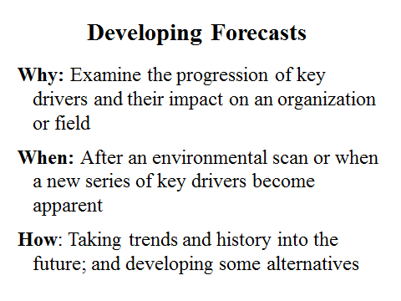
Forecasts provide specific estimations of a particular topic or event at some future time. In the Aspirational Futures approach, forecasts are created using the drivers and key forces identified and explored in the environmental scanning phase. Forecasts are important in providing planning assumptions. They can help determine future courses of action and can also be used to develop goals for an organization.

Forecasts can be developed for key forces, such as drivers (factors that are “driving” the system, or forcing change, e.g. The Affordable Care Act, or for important elements, e.g., the number of lead burdened houses in a city. Forecasts are also developed with varying degrees of quantification and varying assumptions about their accuracy. Use forecasts, ideally multiple forecasts, to assist you in recognizing the range of likely possibilities for any single topic of inquiry.

In doing your research to develop forecasts, collect already available forecasts on the topic where you can find them. For many topics, forecasts have already been done by government, industry associations, specific companies or academics and you can make great use of these. In addition search the Internet to look for “forecasts for a particular area of interest”.

One way to develop a range of forecasts is to start with the “best guess” – the expectable forecast. Move on from there to identify forecasts that provide a sense of what could go wrong and finally, those where things could go right. The drawing in Figure 6 below depicts this framework.

- Alpha forecasts (expectable) -- representing an extrapolation of current forces. This is closest to a most likely extension of current paradigms or conditions relating to the driver. In Figure 6 these forecasts fall into the zone of conventional expectations.

- Beta forecasts (challenging) -- considering some of the many things that could “go wrong.” In Figure 6 such forecasts fall into the zone of quiet desperation.

- Delta forecasts (visionary or surprisingly successful) -- considering potential paradigm shifts particularly that would contribute to more visionary, “surprisingly successful” outcomes. In Figure 6 these fall into the zone of high aspiration.

Figure 6
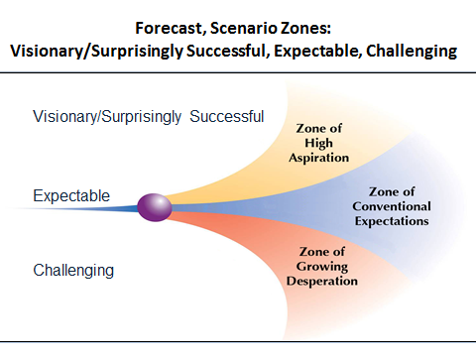

A key use of forecasts is in developing scenarios. You can start by developing the “drivers” shaping the system related to the scenarios, and then develop forecasts for the drivers. Often three forecasts are developed for each driver – an expectable or most likely forecast, a challenging forecast that considers what might “go wrong” and a visionary/surprisingly successful forecast for what goes right. Once the forecasts have been made, they should be discussed with your external stakeholders and policy makers so that you can get feedback on the assumptions you have made in their development. This type of feedback is important, not only can it help ground your work, it can also pique the interest of these two important groups in the process. Even better, involve some of your key stakeholders in scenario development. That gives them a vested interest in what you choose to move forward on.

Special Note: forecasts for most topics involve assumptions about multiple parallel factors – e.g. the number of new automobiles sold in the US in 10 or 20 years will be affected by alternative transportation modes, housing and urban development patterns, the cost of operating the automobiles (including the mix of gas, electric, hydrogen, or other fuel sources), breakthroughs in materials, battery storage, etc. Thus the forecasts for most topics are complex, involving assumptions about multiple factors.

Examples are provided in the online Appendix (http://www.altfutures.org/pubs/WiserFutures/WiserFutures2013Appendices.pdf).

- Scenario Development

- What are Scenarios?

Scenarios are alternative descriptions or stories about how the future might unfold. They compile information about divergent trends and possibilities into internally consistent images of plausible alternative futures. Scenarios are designed to systematically explore future challenges and opportunities and aid in strategy development. In the process, they often provoke the imagination, raise fundamental questions, make explicit our deeply held values, and stretch our worldviews.

Scenarios are not predictions of the future. Rather, they encourage people to think about how to navigate successfully across the different circumstances their organizations might encounter. Scenarios can expand our ‘field of view’ and help people to see possible threats and opportunities that would otherwise have remained hidden.

Scenarios are an investment in learning. A set of several significantly different scenarios helps “bound the uncertainty” of the future so that your organization can systematically plan for future contingencies and clarify the vision of the future you prefer. Scenarios are not an end in themselves – they must be used to be of value.

To foster creative thinking, scenarios should examine a truly broad range of possibilities, not just minor variations. A good set of scenarios will typically contain at least one or more “negative” images as well as a “structurally different” future that challenges current assumptions and explores what a successful future would be like.

Scenarios should map plausible and visionary space. Plausible space incorporates those events that could or might occur – they are not impossible. Visionary space identifies events in “preferred futures” – what you would want to happen. Scenarios help us understand what might happen and explore what could be. Plausible options include visionary options. Scenarios are powerful tools for exploring and creative thinking. The capacity of scenarios to map future space should help us understand visionary or highly successful future states, as well as more conventional and challenging states.

As noted earlier, each scenario set should include three types of futures:

  - Expectable (“business as usual,” or the “official future”). Given all the trends shaping the topic, what is most likely to occur. This is a difficult scenario to determine, but it is essential to identify your best estimate of where current trends are taking us;

  - Challenging (exploring some of the many things that could “go wrong”). Most organizations will avoid considering negative possibilities – it is all the more critical that organizations identify negative events and build a set of those into a challenging scenario; and

  - Visionary (if a critical mass of stakeholders pursued activity that was surprisingly successful).

How quantitative scenarios should be and how specific will depend on their purpose, the group that will use them, and the quantitative data and forecasts that are already available. Scenarios need not be elaborate or highly quantitative to be valuable. This is particularly the case where they are being developed for small community based organizations. Very often, highly quantitative approaches to strategic planning sacrifice imagination and adaptability as they gain quantitative detail. What is most valuable about scenarios is their ability to change the way people who use them think about the future. To do so, the users have to be able to understand the scenarios and how they can be applied in their world.

- Building Scenarios

The steps below outline a process that has proven effective for developing scenarios.

- Clarify your objectives by asking questions.

These will often be strategic questions that the scenarios should help answer. Examples include:

  - What goals should we commit to achieving by the time our organization is 10 years older?

  - How will changes in our environment impact our funding priorities and our scope of work?

  - How do we want to interact with our community partners to insure that we are well positioned in our professional space?

- Identify your target audience

It is important to determine the audience you are interested in sharing your scenarios with. We recommend that you don’t just look within your organization; rather, think about your board or the governing body you report to, e.g. the city council or county commission and your key stakeholders. As recommended earlier, you would want to include individuals from these groups to be part of the scenario development. In the larger sense, these are important groups to test your scenarios out on and get their feedback. If some representative from each group has been engaged in the scenario development, you can ask them to present it to their colleagues. This is an especially effective way to gain the support of these other entities. Carefully setting up a consensus process for scenario development on the front end reduces the roadblocks that you may face in achieving your objectives, especially if their support is key to whether or not you achieve your objectives. In our view, this is one of the most important steps in the process.

Another recommendation is to invite some naysayers into the process. Just a few, but they bring an important perspective. You need to know the kinds of road blocks they might put in front of you as you begin your strategic planning process. The old adage: “keep your friends close but your enemies closer” definitely holds true in this situation.

- Select your approach

Scenarios come in many shapes and sizes so it’s important for you to decide what form your scenarios will take. Pay special attention to electing an option that you think will resonate with your target audience. Here are some you can select from:

  - Write your scenarios as narratives - each of which tells a story, this is by far the easiest approach to start with.

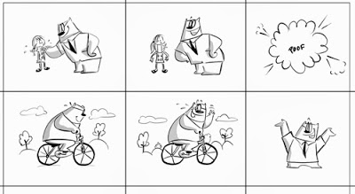
  - You might identify them in a storyboard format with a set of illustrations - a cartoon approach. A storyboard is a written or a graphical organizer with illustrations or images displayed in sequence to assist the developer pre-visualize a motion picture, animation, digital story or interactive media sequence.

  - Write them as a play and then perform them, or–

- If you have a real knack with the computer, consider making them into a video. Who knows, they could end up on You Tube!

Scenarios can be one page each, or the equivalent of a short story, or even a novel - though we discourage using this last example because of the time commitment involved. Besides, it’s quite possible your audience will run out of interest before you run out of words. We suggest that you write scenarios – at least for the first time – as narratives, each being from 1 – 5 pages long. Naturally, your choices of which approach to use will depend on your objectives, your audience and the time and resources you have available.

- Incorporate the key forces driving your system

These key forces will be important in shaping the future your scenarios will explore. For example, will the incentives incorporated in the Affordable Care Act provide an opportunity for the cost of creating a healthy house to become a reimbursable expense under the act?

Some key forces will be important over the whole period of time your scenarios will take into consideration. Others may become prominent earlier (e.g., impact of the 2016 presidential elections on community grant programs offered by the HUD Office of Lead Hazard Control and Healthy Home) or later (e.g., impact on primary prevention after a decade under the ACA) during the time period you are considering.

What is most important is to incorporate the forces you think will be key in driving change over the period of time (e.g. 5, 10, 15 years) you want to explore in your scenarios.

- Look for Wildcards

One aspect of scenario development is to look for Wildcards. Wildcards are high impact, low probability events that are worth considering in any thoughtful look at the future. These include momentous, but unlikely events, such as the discovery of a new energy source or a near-term breakthrough in molecular nanotechnology. While wildcards by nature seem far-fetched, we know that wildcard events have happened in the past. Just think of: the fall of the Soviet Union, the 9/11 terrorist attack, Hurricane Katrina, and the emergence of ISIS in the Middle East.
To ensure that you are not missing major changes, or potential surprises, develop a list of possible “wildcards” that might occur and could be relevant to building your scenarios. Determine whether any of these should be included into one or more the scenarios you create. In any case, hold on to this list as it - along with the scenarios themselves - will identify key factors that you’ll want to monitor subsequently.

- Enumerate key elements

As we’ve discussed above, scenarios are parallel stories about the future – they allow you to compare important factors in each of the different scenarios you create. You’ll want to identify the “elements” that should be defined in each scenario. Elements are found in:

  - the Macro-environment - these factors that affect all sectors, e.g. the economy, global warming, new technologies;
  - the Operating Environment - these are the external factors that are most important to your organization’s operation. For example, how many other organizations in your community are doing similar work and are your competitors in gaining revenue for you to operate; and

  - inside your Organization – these are the internal factors that impact decision-making and your future direction. For example, do you have enough secure revenue sources to allow you to operate over the timeframe you have included in your various scenarios?

Once these have been identified, select the elements you wish to compare.

The key forces identified in Step 4 are elements that can be considered the independent variables driving change. Consider what other elements or important dependent variables or outcomes the scenarios should consider. Develop the elements to compare across the scenarios. Recall the questions identified in Step 1. What elements (and their changes) are relevant to answering the strategic questions you’ve identified? Include these in the lists below. Keep these lists as short as possible, consistent with the time and other resources for the scenario project.

Table 1
Elements to Include in Scenarios
Macro-environment | Element 1:
 | Element 2:
 | Element 3:
 | Etc.
Operating environment | Element 1:
 | Element 2:
 | Element 3:
 | Etc.
Organizational environment | Element 1:
 | Element 2:
 | Element 3:
 | Etc.

- Develop Forecasts for the Key Forces

Develop forecasts for each of the key forces you have identified. Initially, start with forecasts for some of the key forces, perhaps with available government or corporate forecasts, particularly if they are used by your organization. Typically, these “official future” forecasts represent “best guess” extrapolations. It is important to gather this intelligence, because it is often available at no cost to you and can contribute to the development of your scenarios

- Create Scenario Plots

Remember to develop the scenario stories that identify the:

- “most likely” future
- a “challenging” future that considers some of the challenges or negative events, including the “wild cards” identified in step 5,
- “visionary” future in which you create a story about an optimal future.

Note: Do not develop an odd number of scenarios. When you do this, the ‘middle’ scenario is most often identified as being the most probable. Make the choice a bit harder by including 4-6 scenarios. For organizations such as yours, four good scenarios reflecting the options noted above should be sufficient.

Consider the key forces and their trajectories. As you develop your alternative scenarios be cognizant of any patterns that link the driving forces and their impact on the various elements in the scenarios.

  - Be imaginative; consider potential surprises, particularly for a “paradigm shift” – when the usual and accepted way of doing or thinking about something changes completely. Where it makes sense, include them in your scenarios.

  - Define what “visionary” means for your organization and community. If a critical mass of your key stakeholders effectively pursued visionary outcomes, what would they look and feel like? Consider how the key forces and other trends could plausibly lead to surprisingly successful futures.

  - You can start with a set of bullet points for each scenario and then develop a more organized story for each.

  - Most importantly, have fun!

- Create Scenario Matrices

A scenario matrix compares the future condition of the major elements in the Macro - environment, Operating environment and the Organizational environment.

- Decide on the minimal set of elements in relation to the scenarios, viewed through IAF’s Scenario Archetype patterns (see Scenario Matrix below).

- Ensure that the element forecasts are internally consistent within the columns and show the differences where appropriate across the columns in each row.

- Ensure that there are plausible forecasts for all four of the IAF archetypes.

Table 2

Sample Scenario Matrix
Key Elements | Scenario 1:  “Best Guess/  Most Likely” | Scenario 2:  “Hard Times/ Challenging” | Scenario 3: “Visionary A” | Scenario 4: “Visionary B”
Macro-environment
Demographics
Economy
etc.
Operating Environment
Housing Stock
Housing Quality
etc.
Organization
Revenues
Staffing
etc.

- Finalize the Stories & Matrix

Develop/refine the bullet points that tell stories of how the topic of each scenario arrived at its end state, depending upon which ‘out year’ you picked. Write consistent stories. Keep in mind your earlier decisions about narrative length, and whether these will be written, performed, animated, illustrated or some combination of these. Finalize the matrix and carefully heck consistency and effectiveness of the scenario narratives and matrix.

- Do a “test run” with your scenarios. Use this opportunity to consider something, e.g. the “robustness” of a particular strategy, or the strategic questions. Ensure that the scenarios are both internally plausible and consistent and that they are useful for exploring the key questions or strategy in different settings. Adjust as needed.

- Develop a scenario package including, as relevant, introduction, scenarios, exercises, and slides and other presentation material. Use the scenarios and related material at meetings for which they were developed – usually a strategic planning session with staff and your board, or a special scenario workshop engaging your key partners. Using the scenarios both inside and outside the organization puts you in a leadership position of being able to engage people with the future.

A common way that scenarios can be used is to develop “signposts” that indicate that a particular scenario you developed is actually occurring. Every six months after you’ve developed your scenario’s, have a discussion on how the future is evolving in relation to your scenario signposts; communicate your observations to those involved in the process, and integrate them into your ongoing planning and budgeting processes. This will help assure that your strategic plan remains a living document, rather than something you spent a lot of thought, time and energy on only to put it on the shelf.

Again, to emphasize what we said before, how quantitative or qualitative scenarios should be and how specific will depend on their purpose - as defined by you - and the available quantitative data and forecasts. Scenarios need not be elaborate or highly quantitative to be valuable. In fact, in many instances, especially where you are involving community stakeholders, they should be simple and clear so that they are well understood. That way, you will get the best feedback on your efforts.

What is most valuable about scenarios is that they change the way people who use them think about the future.

There are a number of different methods that can be used to create scenarios. See the online Appendix for examples. (http://www.altfutures.org/pubs/WiserFutures/WiserFutures2013Appendices.pdf).

- Using Scenarios

Scenarios are developed and used for a wide variety of reasons. Here are several of the key ones:

  - Expanding Your Field of View: People tend to see what they expect to see. Things that don’t fit into our expectations and assumptions often don’t get noticed. Looking at events through explicit and significantly different images of how events may unfold allow us to see more of what’s happening.

  - Achieving a Strategic Perspective: We tend to be preoccupied with the details of daily news, short-term business tactics, and organizational operations. Scenarios allow us to think about the “big stories” of what is really going on – the major alternative interpretations of what is happening today that are really important and the different ways that events could unfold in the future.

  - Creating a Basis for Ongoing Learning and Strategic Conversation: People deeply involved in scenario thinking become highly motivated to have ongoing strategic conversations about “what’s happening” and “where things are going.” By engaging in this process all participants become more aware of their underlying assumptions and the range of key forces driving change.

  - Generating Creative, Strategic Initiatives: Understanding key forces driving change, thinking strategically about different ways the future might unfold, and clarifying aspirations are ideal preparation for developing strategic initiatives.

  - Keeping You “On Track” Towards Meeting Your Goals: Scenarios can help us think through the changes that may be necessary to keep on track for our goals even if the circumstances we encounter in the future are very different today.

  - Enhancing Participation in Strategic Planning: Conversations and planning exercises developed around vivid scenarios grab people’s interest and make it easier to involve more people in strategic planning efforts.

  - Building Support for New Initiatives: Involving people in scenario thinking, generating strategic initiatives, and evaluating initiatives to identify robust options builds support for the ideas that emerge from/survive this process.

- Framing a Vision

A vision functions as the “north star” for the organization – it defines the destination and sets the direction.

Scenarios identify a range of possible futures – they provide stories of how the future might unfold, including visionary or preferred options. While scenarios are about what might happen, vision focuses on what we want to create.

While trends and scenarios are “futures for the head” that help us think systematically about future possibilities, visions are “futures for the heart.” Visions inspire by stating what we are striving to become, why we do what we do, and what higher contribution flows from our efforts. They touch us and move us to action. A living vision—as opposed to merely words on paper—is something that people share, feel deeply about, believe is possible, and commit themselves to achieving. Creating a vision deals with the ultimate questions facing every individual, group and organization – questions about purpose, meaning, direction, and reasons for existence.
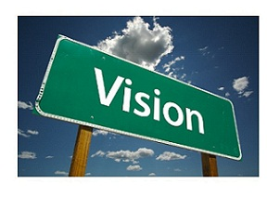
When people are really committed to a vision, they will stretch themselves and their organizations to make it happen. Within organizations, a shared vision allows management to decentralize. Most importantly, people can be given more freedom to act independently and creatively when they have a clear sense of direction and know the importance of their contribution to achieving the vision. A shared vision can also serve as a focus for the collaboration and alignment of efforts by outside organizations.

To be a real force in people’s hearts, and not just words on paper, a vision must meet several conditions:

  - Be legitimate - A vision can never be imposed on an individual or group. To have emotional power, a vision must be inwardly accepted as fully legitimate.

  - Be shared - A vision only works when it is shared. Vision works by posing a collective challenge, aligning people, and generating a group spirit in which people move toward the vision.

  - Express people’s highest aspirations for what they want to create in the world - Self-centered visions that talk about things like ‘being successful’ or ‘making a profit’ inevitably lack emotional power. Goals of this type are perfectly valid, but selecting a vision needs to go further and engage people at the level of their highest aspirations for ‘making a difference.’

  - Stretch beyond the limits of current realities - Visions are not about current reality. They create a tension between current reality and the vision. Visions that command attention always push against the limits of what people have assumed to be possible and challenge them. Challenges that are easy to meet never elicit the best efforts of a group.

A vision involves a commitment to create our preferred future. Our vision takes our values and puts them in place in that preferred future. Visions are most powerful when they reflect our deeper values and purpose. Collins and Porras point out in their book, Built to Last, that organizations that clearly link their values to their vision in ways that motivate their workers outperform their competitors.

Question:
“What’s going to happen to us and our environment in the next 25 years?”

A better question:
“What do we want to make happen?”

Bottom line:
“Vision in not figuring out what is going to change and adapting to it.
Vision is about deciding how we will change the world.”

A vision is about creating the future which involves using creativity itself. Although it might feel somewhat like a catch 22, to create a unique vision you must be creative in framing one. Unfortunately, vision statements are often developed to combat criticism that the organization does not have a vision, thereby subtly reinforcing a problem-solving mind-set, as opposed to a creative one. To get reoriented you will need to shift the conversation from problems to possibilities. That shift is powerful and can lead to a genuine commitment among those involved - getting them excited about working together to create a vision that is powerful. Once stakeholders are engaged, they are excited to collaborate in an environment primed for creativity. This will lead the group to create a vision that is ready to be used and not just a series of words on paper.

A key purpose of a vision is to breathe life into our work in the here and now. A powerful, effective vision is not simply about choosing the right words or even their order, but rather the way the selected words resonate in the hearts and minds of those across the organization.

Most organizations have a mission and a vision. A mission is the statement of purpose for the organization. A vision is the future condition the organization is committed to creating. In many cases these types of visions make a difference. In other cases, where the organization’s vision has little meaning – the organization is not creating the future they prefer – particularly not one that follows their values. Since most organizations already have a vision, much vision work involves examining, revising, and recommitting to the vision.

In working to help organizations develop visions to orient them to their higher aspirations, we have found it useful to distinguish between different types of visions.

- A Statement of identity is an inspiring statement that unifies people by asserting their shared identity. The most powerful statements of identity often refer to motivating archetypes that are widespread across human societies.

- A Statement of values identifies the motivating principles of an organization. The vision of the World Health Organization, of “Health for All” includes key values: equity, solidarity, sustainability, ethics and human rights.

- A Description of a preferred future is the most literal vision. Compared to statements of identity or value, it is a more detailed and objective description of the future where the ultimate aspirations of the organization are fulfilled.

It is not necessary to choose just one of these approaches. The best visions often contain a blend of different emphases.

In the online Appendix IAF provides a range of different vision statements: (http://www.altfutures.org/pubs/WiserFutures/WiserFutures2013Appendices.pdf). There are examples of statements of identity and values, and descriptions of preferred futures. IAF also shows its own vision as an example of “blending types” to create a compelling vision.

- Audacious Goals (BHAGs)

Once an organization has a vision, then Audacious Goals are needed. Use the vision to create BHAGs that are bold enough to make people ask themselves “Is this really possible?” Once the answer is “Yes,” the vision and BHAGs’ very boldness becomes a major source of its power.
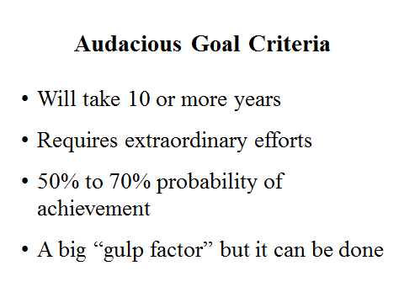
Because they articulate a daring adventure with important outcomes, these goals give people the sense they can make important contributions and surpass what they thought were their personal limits. They need to be clear and compelling but with measurable outcomes. They serve as a unifying focal point of effort and act as a catalyst for action.

Examples of BHAGs

The great science and science fiction writer Arthur C. Clarke once said that there are four stages of reaction to any truly new idea or audacious goal:

- It’s Crazy!
- It might be possible, but so what?
- I always knew it was a good idea.
- It was my idea.

Maybe, as George Bernard Shaw once stated, “Progress depends on the unreasonable man (or woman) who is willing to pursue goals that others dismiss as unattainable”. What follows is a short list of what might be termed “unreasonable” goals that stimulated great achievements, both in the public and private sectors.

- Put a man on the moon. John F. Kennedy

- Prevent and eradicate polio. Jonas Salk

- Sequence the Human Genome. James Watson

- Create a computer a child can use. Steve Jobs

All these goals share a common set of attributes, they:

    - Go beyond what most people have assumed is possible or reasonable,

    - Are seen (correctly) by some as achievable,

    - Engage and energize people (once accepted, their boldness grabs people in the gut),

    - Go beyond “being number one,” “making a profit” or “getting re-elected” to higher aspirations for “making a difference in the world,”

    - Motivate and align efforts, stimulating forward progress throughout an organization or across multiple organizations,

    - Continue to drive progress regardless of what happens to their originator – taking on a life of their own.

    - Easily explainable

What BHAGs can you identify for your organization?

- Understanding and Leading Change¹

- Introduction

To be successful today, organizations must be able to change. However, knowing how to manage change effectively is often elusive. In fact, many change initiatives never get past the initial implementation phase, much less making it to their first birthday!

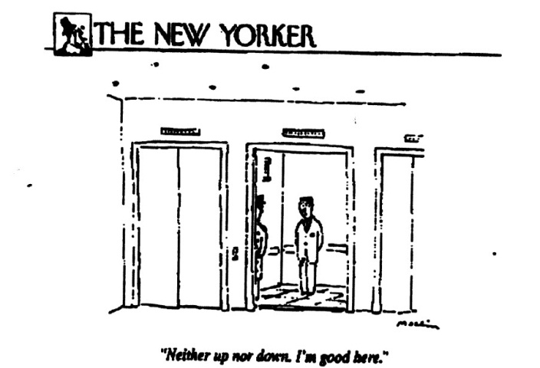
Organizational change is so difficult because it involves people. If we could do without them it would be a breeze. However, it’s part of the human condition that, in the face of change, we like things the way they are. We all resist change that requires us to get out of our comfort zone. It’s fascinating to me that often when I begin working with an organization I run across employees – well known chronic complainers - who, in the face of change, believe their circumstances are just fine.

Bottom line: if you can't motivate people to change, you can't change the organization. And if the organization can't change, long-term success is not achievable.

Through my executive coaching experience, I’ve identified five core change strategies, that when adopted, greatly enhance an organization’s ability to be effective. They are:

  - Defining your destiny
  - Clarifying values
  - Leading with authenticity
  - Managing change effectively
  - Balancing priorities

1
The material in this section has been adapted from Dr. Shaheen’s chapter on the topic published in Roadmap to Success, by Insight publishing.
Although it covers new material, it also provides a review of many of the topics covered in the prior sections.

Figure 7

Five Core Change Strategies

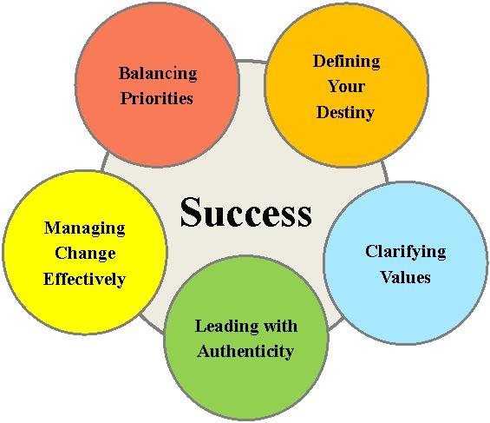

Note: It is important to remember that all five are interconnected and are not necessarily sequential. You may start with number one and then find that you have to skip to number three. Then you may have to circle back to number one before moving to numbers four or five. Thus the sequencing is iterative rather than linear.

Defining Your Destiny. As was discussed earlier, the key to being successful is using a proactive rather than reactive approach. Organizational leaders need to create a preferred future. Responding only to the immediate crises is a recipe for disaster. Forecasting and scenario planning are the tools for accomplishing this. Ultimately, the outcome from these exercises is to pick a ‘preferred future’ that can then form the basis of your strategic planning effort. As you move forward, make sure you are setting stretch goals and, most importantly, that you and your board are willing to task a risk. Conservative planning will not get you far in our fast changing world.

Using the term preferred future is intentional - the use this term is very important. It changes people's mindset. When you from “what do we have to do” to “what do we want to do” there is a very powerful paradigm shift.

Clarifying Value. This is a critical step – especially given the role that ethics plays in the organization. The purpose of establishing organizational values is to create a code of conduct – one that builds a cohesive culture and supports the vision of the organization. Values are demonstrated through organizational behavior. The phrase ‘walking the talk’ means there’s no difference between values and behaviors. Values ‘talk’. Behaviors ‘walk’.

When an organization’s values are made explicit, employees can assess the degree to which their values align with those of the organization. Where this is the case, research has identified some interesting findings: increased productivity; reduced employee turnover and increased employee satisfaction. When values are clarified, organizational change becomes easier.

Richard Barret, an executive coach, wrote Liberating The Corporate Soul: Building a Visionary Organization, a book I have found to be exceptionally useful. One of my favorite quotes from his book is: “Through living their values, visionary organizations find a balance between organizational needs for survival and growth, employees’ needs for personal fulfillment, and the local communities and society's needs for economic, social, and environmental stability.” Values then, drive the corporate vision – providing the framework within which every member of the organization can operate with responsible (the key word) freedom.

Lead with Authenticity. ‘Leadership is not about what you do, but about who you are’. Authentic leaders have no problem answering the question: “how do I show up at the office every day”. They know who they are. This may sound trite, but many leaders know more about their favorite sport, restaurant, or vacation spot than they do about themselves! Contrary to popular opinion, leaders are not judged by how well they have lead but rather by how well they have served: their board of directors, their employees, their constituents and their community. In this context they are servant leaders – a term coined by Robert Greenleaf, in his seminal book: On Becoming a Servant Leader.

It is also important to realize that anyone in the organization can be a leader. The focus of their leadership may be different – some create value through ideas, others through systems and still others through people. However it’s expressed, it’s still leadership that needs to be nurtured. This is an important dynamic to understand. The ‘command and control’ model, the hierarchical top down form of leadership, which was the hallmark of the last century, no longer works. Just think about the leader whose staff is spread around the globe! This leadership style has been replaced by a new model called networked leadership developed by Frances Hesselbine. When describing her organizational structure to a New York Times reporter, she put a glass at the center of a lunch table and created a set of concentric circles radiating outward—plates, cups, saucers—connected by knives, forks and spoons. "I'm here," she said, pointing to the glass in the middle. "I'm not on the top of anything."

To empower employees, authentic leaders provide them with needed information and give them authority to make relevant decisions. In recognition of the degree of leadership that permeates the organization, employees must be given the tools they need to work with and must be trained so they can incorporate into their leadership style the behaviors and capabilities needed to be good decision makers.

Believe in what you're doing and be passionate about it. Research has consistently shown that individuals passionate about what they do are peak performers. Passion provides the energy you need to continue the work you are doing work. Let your employees know how passionate you are. Being passionate catalyzes others to move forward with you - even though the path might not be entirely clear. If you are not passionate about what you are doing, you need to be doing something else.

Remain tenacious. Managing change is a difficult, sometimes thankless job. Personal tenacity – a belief in yourself and confidence in where you are going, even though the way may be somewhat murky – is critical. I guarantee there will be times when you are going to want to throw in the towel. That’s when personal tenacity really comes into play. You have to be willing to go the distance.

Managing Change Effectively. As a starting point, it’s very important to identify the core things about the organization that should not change and those things that should be open to change. You need a key understanding of those aspects of the organization that should not be subject to change and what is. Obviously, vision and values play key roles in making these decisions.

When I begin the dialogue with clients, I always introduce the topic with the following quote made by a colleague of mine, Stu Altman, an economics professor at Brandeis University. From Stu’s point of view – “everyone is in favor of progress – it’s change they don't like.”

This expression has resonated with every CEO and team I have ever worked with. If truth be told, executing a change strategy within an organization is really, really hard work. Unfortunately, enough, the process of how to go about it is often given short shrift. Issuing a memo or having staff attend an informational meeting where the change is announces, doesn’t cut it. Change doesn’t’ happen if you don’t have a ‘roadmap’ of where you want to go and how to get there.

Although there are many models of how to managing change successfully, the model I use is based on the work of John Kotter and William Bridges – both seen as change gurus. I've enjoyed integrating the two models and believe the model I have created provides an effective way of dealing with both the intellectual and emotional aspects of change. Most leaders are very comfortable with the first but moving into the emotional aspects of change – the ‘warm and fuzzy’ side of leadership – is very difficult. Ironically, the emotional aspects are the most important to address if you really want to get to your goal

This is one of the reasons I introduce the topic of authentic leadership just prior to this one. The earlier discussion provides a context for dealing with the emotional aspects of the change process in a more comfortable way.

Over the years, there are several maxims I have gleaned from working with leaders responsible for managing change in their organizations. These are:

- There is no change for change sake – in order to get people out of their comfort zone – you need to create a crisis.

- You can’t work with everyone at once. Create a strategy group to ‘work the problem. Populate the group with more than the usual cast of characters. Membership should include representatives from all parts of the organization. I’m always amazed at creative employees are when employees are asked for their input. Not only that, but once committed, they will be your advocates in selling the strategy down the road. be if asked for input on the best way to manage change at their level in the organization.

- Generate ideas, and remember, any idea can be a new idea – even though you tried it ten years ago.

- Watch out for the naysayers– they are definitely out there. Often they’ve been around for years and have been subject to past change efforts to change. Given the frequency with which prior efforts fail, they can be quite jaded about this round. Know who these people are and develop a counter strategy to address their negativism.

- Just like spaghetti, throw some of new ideas against the wall. Then, take the ‘sticky’ ones out for a trial run. Do not be afraid to fail! It’s important to take a risk. If you don’t, why should anyone else?

- Host a funeral and then throw a party! It’s important to realize that making change, regardless of how beneficial, leads to losses. Once a strategy has been selected, honor employee’s concerns, don’t pretend they don’t exist. A funeral allows people to say goodbye to what is being left behind –maintaining employee morale and commitment to moving forward.

Celebrating is also important. As I often say, congratulations, you’ve jumped off a cliff and landed on a cloud. How great is that!

Balancing priorities – is one of the most important, yet often the most overlooked. Managing change is HARD. It’s intense, difficult and fraught with frustration. Sadly, leaders often defer taking care of themselves – both physically and mentally until something wears out. One of the observations I use to make the point is: “Take care of your body. It’s the only place you have to live.”

Your personal and professional lives also need to be balanced. One is not separate from the other and both need attention. Unfortunately, in many leaders engaged in these processes, the personal side often gets short changed. When it does, there are other negative consequences that have to be faced. So plan accordingly. Bottom line: if leaders burn out, there’s a good possibility the change process will flame out.

- Concluding Comments

Using futures tools to better understand what might happen and better create the future you prefer is what Aspirational Futures and this workbook are about. Use this workbook and the Appendices on IAF’s website to get started and to check your progress. Scanning the environment, developing forecasts and scenarios, formulating powerful; shared visions and audacious goals are all relevant tasks – and they are essential for leading change.

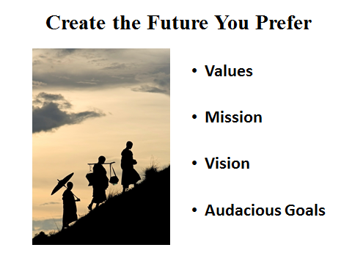

We wish you luck in understanding and creating your preferred future!

- Appendices

Appendix 1

Futures Terminology

Aspirational Futures – Approach of the Institute for Alternative Futures to enhancing understanding about the future and the ability to create preferred futures. Understanding the future involves using futures tools, particularly trends, forecasts and scenarios to explore what “might happen”; these consider “plausible futures”. Creating the preferred future requires understanding the environment; but it is even more important to clarify our values and our identity in defining our vision. Vision requires a commitment to creating our preferred future. Audacious goals and strategies focus on targets and approaches to creating our preferred future (in light of the environment). Creating the aspirational future deals with the “preferred future,” intent and commitment. IAF has developed ways to ensure that forecast and scenario development explore key uncertainties, including paths to the visionary outcomes of aspirational futures.

Aspirations Model – In pursuing aspirational futures, IAF often encourages the use of the “aspirations model” developed by Roger Fritz. The aspirations model differentiates aspirations, behavior and circumstances, allowing the individual or organization to consider to what degree they are creating their preferred future or allowing their changing circumstances to shape their directions.

Drivers – The forces that move a system. They are trends that act as independent variables, often with the greatest impact.

Foresight – Foresight involves taking a longer and broader view of decision-making. Foresight is used to provide early warning of emerging issues, understand challenges and opportunities, clarify vision and goals, and check the appropriateness and “robustness” of strategies. Foresight enables organizations, agencies, and communities to more wisely create their futures. Foresight is essentially about the future – a place for which there are no facts (it has not occurred yet). Key approaches to foresight include monitoring trends, developing forecasts and scenarios, checking assumptions and mental maps.

Futures – A term referring to the time yet to come. It is plural because one of the fundamental beliefs of futurists is that the future is not predetermined, or pre-ordained, rather it is created by each of us. Therefore, there is no single, certain future, but only alternative futures.

  - Possible Future – the range of possibilities that might happen, including a future formed by wildcards.

  - Plausible Future – the forms the future may take which are more likely than the possible future, and generally more visible from looking at current trends. Often a “best guess” estimate of the future can be compiled from available trends and intelligence. In many cases governments will give a base forecast on which policy is based. These represent “the official future” type of plausible future.

  - Preferable Future – the desired future for an organization or community and is also called the preferred future.

Goals – Specific objectives that are measurable and achievable in a specified time frame.

  - Big Hairy Audacious Goals (BHAGs) – clear and compelling but measurable outcomes, which serve as a unifying focal point of effort and acts as a catalyst for action; generally these represent a “stretch” from the present.

Key Forces - Trends that are driving change in the system being considered.

Mission – Specifies an organization’s role in achieving a vision. It does not contain specific strategies or goals; rather, it clarifies the purpose and scope of the organization and what the organization will do to pursue their vision.

Scanning – Observing changes in the environment (or parts of the environment) by monitoring information sources. Scanning can be focused on a topic (e.g. cancer breakthroughs), or an issue, or on an open horizon in search of an issue or trend that is emerging. Increasingly scanning is done on the Internet, through aggregating services, or networks.

Scenarios - Plausible descriptions of how the future might unfold. Generally scenarios are a set of parallel, holistic pictures which integrate multiple forces and consider their impacts on various elements of the system.

Scenario Archetypes – A technique developed by the Institute for Alternative Futures (IAF) to ensure a spread of future environments within a scenario set and provide effective learning for both understanding and better choosing the future. The archetypes move through a “most likely” or “official future” (alpha) to a “what could go wrong” hard times scenario (beta), then to two structurally different scenarios, at least one of which should be visionary (delta).

Scenario Levels – Depending on the key questions or issues to be addressed, scenarios portray change at various levels.

  - Macroenvironment – the larger social, economic, political, technological and ecological setting in which the company and its industry exist.

  - Operating Environment – the forces that are most important to a particular industry or organization.

  - The Organization – alternative futures for the organization rather than its environment.

Scenario Matrix – Enables the comparison of the scenarios in a set across specific elements. Scenario elements such as the economy, technology, health access and promotion are listed along the right side of the matrix, and each scenario is listed across the top. These elements and the forecasts for them in each scenario are sometimes grouped into the “macroenvironment” (e.g., society and the economy), the operating environment (e.g. health care delivery elements) and the organization.

Strategies – Integrated patterns of actions aimed at achieving the vision.

Trends – A pattern of change over time in something of importance for the observer.

Value – A basic belief in what is good and true, values can be seen as desirable qualities.

Vision – A compelling, inspiring statement of a preferred future that the person or organization is committed to creating. A vision provides a “north star” for an organization; it links the values of the organization to the future they want to create. It makes workers more productive; vision work may confirm and renew commitment to a current vision or create an enhanced vision. It does not specify any plan or method for achieving the vision; rather, it serves to inspire and align people and organizations around a noble goal. A shared vision that touches people’s hearts is one of the most powerful tools for change.

Weak Signal – A weak signal is an indicator of impeding change built on the base of (internal or external) environmental scanning. They point to the emergence of challenging transformations that have strong implications for the future.

Wild Cards – Low probability but high impact events. They represent events, such as the fall of the Berlin Wall in 1989, the 9/11 terrorist events in the US, the Asian Tsunami of December 2004, which were unanticipated (even though with hindsight, they seem remarkably plausible). Wild cards such as political revolutions or environmental catastrophes prompt consideration of significant but inadequately considered factors.

Appendix 2

Additional Futures Resources

One of the keys to any futures process is starting with a good set of resources. The lists below provide some starting places for your futures process. The books listed cover an array of futures techniques should you wish to learn more. IAF also recommends looking to futures journals, magazines and website. They can be an excellent source of further information on futures and a good source for environmental scanning.

Futures Magazines and Journals

The Futurist – The Futurist is a publication of the World Future Society. Each issue contains feature articles written by outstanding experts in a wide range of fields: business, creativity, education, economics, environment and resources, values, and more.

Futures – Futures is a refereed, international, multidisciplinary journal that covers the medium and long-term futures of cultures and societies, science and technology, economics and politics, environment, individuals and humanity. It also covers the methods and practices of futures studies.

Foresight: Journal of Futures Studies, Strategic Thinking, and Policy – Foresight is an international bi-monthly journal concerned with the study of the future. It combines peer reviewed articles with topical commentaries.

Journal of Futures Studies – The Journal of Futures Studies is a globally-oriented, trans- disciplinary referred journal. It provides futures-oriented research and thinking based on the evolving discipline of Futures Studies.

Technological Forecasting and Social Change – A journal dedicated to the methodology and practice of technological forecasting and future studies as planning tools as they interrelate to social, environmental and technological factors.

World Future Review: A Journal of Strategic Foresight – The futures journal of the World Future Society is published bimonthly.

Websites

Institute for Alternative Futures (www.altfutures.org) – The Institute for Alternative Futures website provides an array of information and reports using futures techniques on associations, the environment, government, health and education.

The World Future Society (www.wfs.org) – The World Future Society website has a wealth of information on futures and other subjects. They also publish The Futurist and the electronic newsletter Futurist Update.

Global Business Network (www.gbn.com) – Founded by Peter Schwartz, owned by the Monitor Group, and currently Deloitte, The Global Business Network was a worldwide learning community of organizations and individuals connected by the open and generous exchange of ideas, "out-of-the-box" scenario thinking and ruthless curiosity. There website retains examples of their work.

Institute for the Future (www.iftf.org) – The Institute for the Future (IFTF) is an independent futures research group.

World Futures Studies Federation (www.wfsf.org) – The World Futures Studies Federation is a global network of practicing futurists -researchers, teachers, scholars, policy analysts, activists and others from over 60 countries.

Shaping Tomorrow (www.shapingtomorrow.com) – This significant scanning source based in the UK has environmental scanners and trend researchers cover over 7,000 websites of the futurist community, strategists, and the private libraries of key organizations. Shaping Tomorrow has developed a collective trend monitoring network that serves a larger number of individuals and organization. There is an initial level of access that is free, then various levels of paid access. There is also a Shaping Tomorrow Foresight Network for networking among futurists and futurist educators (http://shapingtomorrowmain.ning.com/)

Rockefeller Foundation Searchlight effort – This is a major international scanning effort by the Rockefeller Foundation. This is a first-of-its-kind trend monitoring effort in the philanthropic sector that gathers cutting-edge intelligence with a focus on on-the-ground problems and solutions. This intelligence is provided by a group of 12 forward-looking, regionally-focused horizon scanning and trend monitoring organizations that conduct regular, ongoing scanning for novel ideas, research results, and “clues” as to where the world is evolving, in particular with respect to the lives of poor and vulnerable populations. Selected newsletters are available at http://www.rockefellerfoundation.org/what-we-do/research- records/searchlight-newsletters.

Appendix 3

Additional Resources for Environmental Scanning

Futures Organizations, Futurists, and Refereed Futures Journals: A number of excellent futures organizations publish regular articles and reports on futures subjects topics. These organizations often do routine scanning of sources and have expertise in certain fields of interest. Their publications often include forecasts, wildcards or scenarios. Many futurists also publish regularly in futures magazines and journals or have their own newsletters and blogs. Moreover, there are several refereed futures journals which cover developments in the field, including corporate, community and government futures efforts and applications. Links to these futures organizations are available in the “additional futures resources” section of this compendium. Examples include:

- Futurist Organizations: Institute for Alternative Futures, Institute for the Future, and World Futures Society.

- Refereed Futures Journals: Futures, Journal of Futures Studies, foresight, Technology Forecasting and Social Change, and World Future Review.

Artistic and Visionary Works: Novels, movies and other art can be a valuable source of scanning material. These materials can provide important insights on the future. They are particularly useful for identifying important trends in the social, political and values framework. While these works of art rarely provide ‘accurate’ views of the future, they can help frame important questions and provide some of the earliest indications of important trends. Classic examples include Aldous Huxley (Brave New World), George Orwell (1984), Ray Bradbury (Fahrenheit 451), William Gibson (Neuromancer), and Neal Stephenson (The Diamond Age).

Think Tanks: Think tanks are a great source of in depth analysis and data on the most important trends in the larger environment. Think tanks are often among the first to do in depth analysis of emerging issues. Edgier think tanks also explore issues in depth and brainstorm solutions to problems well before they hit the mainstream consciousness. Many think tanks also regularly publish their work online in the form of journal articles, op/ed pieces and white papers. Regularly reviewing the e-newsletters of think tanks can be an effective way to spot emerging issues before they reach the main stream press. Examples include:

- Multi-Issue Think Tanks: Pew Research Center, Brookings Institute, the American Enterprise Institute, the Center for Strategic and International Studies, CATO, New America Foundation and RAND, Chatham House.

- Edgier Think Tanks: Rocky Mountain Institute, Center for Neighborhood Technology, the Worldwatch Institute, Demos, and the Santa Fe Institute.

Professional Literature: Professional literature is an important part of any scanning process. It includes scientific and technical journals and the publications of professional associations. Scientific and technological literature is often where disruptive technologies first appear. Professional journals can also be valuable sources of data on social, environmental and economic trends. Some professional literature, especially for scientific professions, can be difficult to interpret for those outside the profession. Evaluating the experience of the staff designated to the scanning process is important for deciding what journals to include in the scanning process. Examples include:

- Business: Harvard Business Review and the MIT Sloan Management Review.

- International Relations: Foreign Affairs, Foreign Policy and Harvard International Review.

- Medical: New England Journal of Medicine, Journal of the American Medical Association and the Lancet.

- Science and Technology: IEEE Spectrum, Nature and Science

Popular Media: Certain popular media sources can be an excellent source for scanning. They can often provide good coverage of an emerging trend. However, by the time a trend is profiled in the popular media it is often fairly well developed. This can reduce the competitive advantage of scanning. Blogs and internet newsletters can also be good places to scan. However, the quality and reliability of blogs and internet newsletters can often be suspect – it is a good idea to check the background of the writer if possible. Good popular media sources tend to specialize in certain areas and are able to devote significant time and attention to an issue.

Appendix 4

Sample Workshop Exercises on Using Future Tools

- Environmental Scanning

Environmental scanning should identify changes taking place, and ideally, anticipate changes by spotting them in their early phases.

- How consistent and effective is your personal or organizational scanning?

- What else should you be doing to scan more effectively or learn from the scanning you’re doing?

Discuss your answers in pairs with your organizational team.

- Developing Forecasts

For safe and healthy homes arena there are many important topics that would be relevant to have forecasts for – e.g. funding, others in the community doing safe & healthy homes work, technology changes increasing or decreasing housing health and safety, awareness of home health and safety issues. Consider what factors are most important for shaping home health and safety.

- Choose the topic you want to forecast.

- Given the topic you have chosen, develop three parallel 5-year forecasts to 2020, for where that topic will go:

  - Expectable Forecast - Think about how and where that driver will evolve over the next five years. Write what you think is the “most likely” forecast in the "Expectable Forecast“.

  - Beta Forecast - Then develop a Beta or challenging forecast. Consider “what could go wrong” related to that driver and how that might shape your topic. Assume that some of those things do go wrong and develop a 10-year forecast.

  - Delta Forecast - Next develop a Delta or surprisingly successful/visionary forecast for your driver. What are the positive, successful directions for your driver (successful here generally means that the driver will shape your topic in positive or successful directions)?

2020 Forecasts

Topic for these forecasts:

Expectable forecast
Challenging forecast
Visionary forecast

- Scenario Development

- You’ve developed forecasts for important drivers. Think about the other important drivers. Think about how they will interact and what types of futures might evolve by 2025. Develop those into the outlines or framework for three scenarios for safe and healthy housing.

- In small groups, discuss:

  - What would be the most important 4 to 6 drivers for safe and healthy housing?

  - Develop (1) expectable, (2) challenging and (3) visionary forecasts for those drivers you did not work on in the last exercise.

  - Consider the driver forecasts then complete a scenario matrix similar to the sample matrix found on page 23 (Table 2).

  - Identify a title for each scenario and develop the outlines/frameworks.

Scenario 1: Title and outline

Scenario 2: Title and outline
Scenario 3: Title and outline

- Framing a Vision

A vision is the preferred future you are committed to creating. Visions act as a “north star”, setting inspiring directions for the organization and its members. Visions are not about reality, but about the future you are committed to creating.

- Consider your organization’s vision – what is the north star it paints?

- Does it touch and motivate those in the organization?

- Does it need to be enhanced, revisioned, or communicated with more inspiration?

- Developing Audacious Goals - BHAGs

- Consider the significance of your organization’s vision. Identify two Big Hairy Audacious Goals (BHAGs) that are stretch targets, moving toward achieving the vision.

- Consider these criteria:

  - GULP - Dare to achieve something great!

  - GRASP - Clearly defined

  - GO - Exciting enough to pursue

  - DARE - Commit to accomplish

  - MEASURABLE - Know when you achieve success; who does what by when.

  - A STRETCH - Each BHAG should be clear, compelling, not be a “shoe in” (50 to 70% likely), but achievable if the organization is committed to it.

