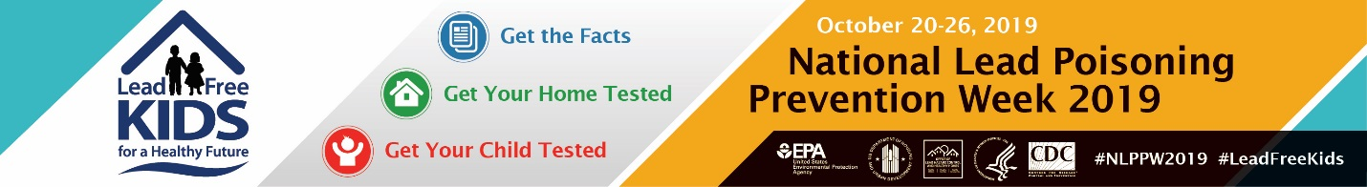
National Lead Poisoning Prevention Week 2019:
Communities in Action, Policies in Action
A Twitter chat presented by the National Center for Healthy Housing
Tuesday, October 22, 2019, 3 to 4 p.m. ET (12 to 1 p.m. PT). #NLPPWchat
The National Healthy Housing Center (NCHH) is hosting its third annual Twitter chat (#NLPPWchat) during National Lead Poisoning Prevention Week to spread awareness and take action on lead poisoning prevention and response policies. The #NLPPWchat aims to:
- Discuss lead poisoning prevention and response.
- Raise awareness about the sources of lead exposure.
- Share helpful initiatives, policies, and resources.
NLPPW partners, please:
- Participate in the live chat on October 22 at 3 p.m. ET (12 p.m. PT).
- Help promote #NLPPWchat widely to your followers, members, and partners to ensure broad participation.
To participate, follow @NCHH and RSVP at http://bit.ly/NLPPWchat. On October 22, @NCHH will post questions starting at 3:00 p.m. ET (12:00 p.m. PT). Follow along using the #NLPPWchat hashtag and share your thoughts and ideas on policies and practices to address lead poisoning prevention and response. Be sure to include #NLPPWchat in your tweets so that the chat participants can easily follow you and others during this event.
Promote the chat widely for maximum participation! Find social media tools at http://bit.ly/NLPPW2019. Also, follow @NCHH and retweet our Twitter chat promotions in the days leading up to the chat.
You have an excellent opportunity to highlight some of your exciting initiatives and projects! Use the #NLPPWchat questions to formulate your answers now.
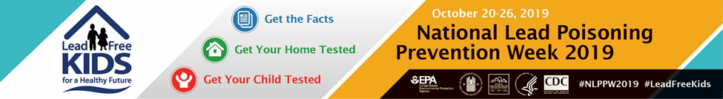
Have a Conflict?
If you’re scheduled to be elsewhere but would still like to participate, you have options! It’s okay to join the chat late. As long as you’ve identified which answers correspond to what questions, the audience will figure everything out. Another option is to pre-schedule your tweets using TweetDeck, Hootsuite, or other tweet/post management service.

Don’t forget to revisit the chat when you can, either on Twitter or in curated form via Wakelet. (The Wakelet link will appear on our dedicated National Lead Poisoning Prevention Week page later that week: http://bit.ly/NLPPW2019.)
Format Your Tweets
When writing your tweets, be sure to remember these tips:
- Include the hashtag #NLPPWchat in all of your tweets.
- Start your answers with A1, A2, A3, et cetera, to correspond to the question number.
- You have only 280 characters per tweet, including spaces and links, but you’re not limited to one tweet per answer to a question. You may also use A1a, A1b, A1c, and so on, to indicate a multipart answer or multiple responses to a given question.
- Use links to your website, programs, initiatives, and partners in your tweets! Promote the good work that you and your community or organization is doing! (Note that links on Twitter always use 23 characters, regardless of their actual length.)
Join us for what should be a lively and informative discussion and let us help you to highlight all of the exciting work you are doing to prevent and respond to lead poisoning!

If you haven’t already, RSVP here now! http://bit.ly/NLPPWchat

The #NLPPWchat question schedule begins on the next page.

#NLPPWchat Question Schedule
To help you out, we’ve preformatted the answers for you. To appear in the chat, your answers must include the #NLPPWchat hashtag. You may also want to include the #NLPPW2019 hashtag, which heightens your post’s visibility during National Lead Poisoning Prevention Week; however, this is optional.
3:00 p.m.
Check-In Question: What is your organization's mission, and how does that relate to lead poisoning prevention? #NLPPWchat #NLPPW2019
A: #NLPPWchat #NLPPW2019
3:09 p.m.
Q1: What are the top three things that people should know about lead exposure? #NLPPWchat #NLPPW2019
A1: #NLPPWchat #NLPPW2019
3:14 p.m.
Q2: How are housing codes used—or how could #housingcodes be improved—to address and prevent lead exposure? #NLPPWchat #NLPPW2019
A2: #NLPPWchat #NLPPW2019
3:19 p.m.
Q3: What policies, programs, or efforts make a difference in preventing and responding to childhood lead poisoning? (Please share links and resources.) #NLPPWchat #NLPPW2019
A3: #NLPPWchat #NLPPW2019
3:24 p.m.
Q4: What organizations do you partner with to address lead exposure? #NLPPWchat #NLPPW2019
A4: #NLPPWchat #NLPPW2019

3:29 p.m.
Q5: Why is it important to test rental units and owner-occupied homes for lead hazards? What else should be tested for lead hazards and why? What resources are available to test and/or remediate lead? #NLPPWchat #NLPPW2019
A5: #NLPPWchat #NLPPW2019
3:34 p.m.
Q6: How do you or your partners use data to improve testing rates, to target resources, and/or to identify at-risk housing or families? #NLPPWchat #NLPPW2019
A6: #NLPPWchat #NLPPW2019
3:39 p.m.
Q7: Who else needs to hear about childhood blood lead testing rates and requirements? How aware is this audience, and how can we raise awareness and increase testing? #NLPPWchat #NLPPW2019
A7: #NLPPWchat #NLPPW2019
3:44 p.m.
Q8: What strategies do you recommend to get more kids tested or to convince leaders to advocate for increased testing? What has succeeded and should be implemented more widely? What hasn’t yet been tried but should? #NLPPWchat #NLPPW2019
A8: #NLPPWchat #NLPPW2019
3:49 p.m.
Q9: How have foundations and philanthropists invested in childhood lead poisoning prevention and response? How can and should philanthropy and government join forces to serve communities impacted by lead hazards and childhood lead exposure more effectively? #NLPPWchat #NLPPW2019
A9: #NLPPWchat #NLPPW2019
3:54 p.m.
Q10: “Health in All Policies” (HiAP) is a collaborative approach to improve the health of all communities and people by integrating and articulating health considerations across all sectors of policy. How could/does #HiAP work with #leadpoisoning prevention? #NLPPWchat #NLPPW2019
A10: #NLPPWchat #NLPPW2019

